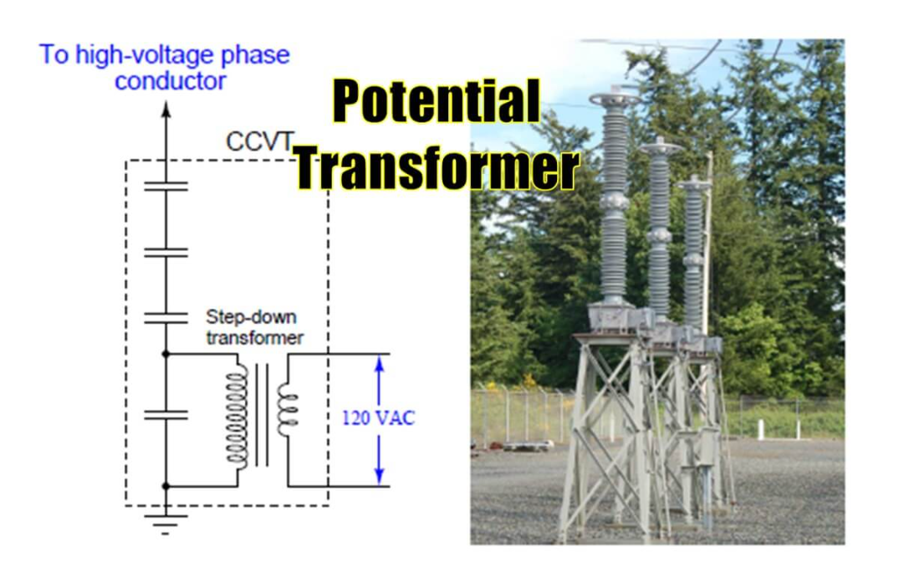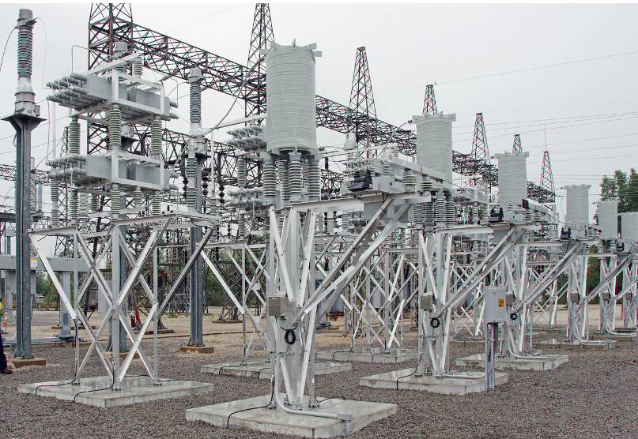

PT and CT in Transformers: The Unsung Heroes of Voltage and Current
When it comes to transformers, PT (Potential Transformer) and CT (Current Transformer) are like the dynamic duo of the electrical world—Batman and Robin. They may not hog the spotlight like the transformer itself, but these two work behind the scenes to ensure everything runs safely and efficiently. Let’s dive into how they work their magic in different transformer setups.

PT: The Voltage Whisperer
The Potential Transformer (PT) is your go-to guy for stepping down high voltage to a manageable level. Imagine you're dealing with a monstrous 33 kV (or even higher) in your power system—dangerous and definitely not something you'd want to measure directly. That’s where PT comes in. It converts those hair-raising voltages into something your meters and relays can handle without breaking a sweat, usually stepping it down to something like 110 V or 120 V.
So, where do you find PTs in action?
- High-voltage transmission transformers: These are the big guns of the power grid, handling voltages anywhere from 110 kV to 765 kV. PTs here make sure you can monitor and measure voltage safely from afar.
- Substation transformers: PTs work in substations to monitor and control voltage levels before it’s distributed to industrial or residential consumers.
- Protection and metering transformers: In systems where voltage monitoring is critical for safety and billing, PTs step in to provide accurate voltage readings for control rooms, relays, and protection devices.
PT is like the calm, collected translator at a loud electrical concert, taking those ear-splitting 110 kV notes and turning them into a gentle hum your equipment can handle.

CT: The Current Tamer
Now, let's talk about the Current Transformer (CT), the power system’s personal trainer. When the current starts flexing its muscles with thousands of amps flowing through your transformer, CT steps in to tame it down to a safe level—usually in the range of 5 A or 1 A.
You’ll find CTs hanging out in:
- Distribution transformers: These guys serve residential or commercial areas, typically running at voltages like 11 kV to 33 kV. CTs here ensure current monitoring and protection, keeping tabs on how much juice is flowing through the lines.
- Power transformers in substations: CTs monitor the current at high voltage substations where transformers step down voltage from transmission levels (e.g., 132 kV or higher) to distribution levels. They’re vital for detecting faults and triggering protection devices before something goes wrong.
- Industrial transformers: In factories or heavy industrial zones, transformers often handle hefty loads, and CTs are there to monitor massive currents. If something goes wrong, the CT relays the information to protection systems that shut things down before equipment gets fried.
Think of CT as the bouncer at a club—it keeps the current in check so that it doesn’t overwhelm your protection systems, and if things get too rowdy, CT makes sure someone hits the emergency stop.

Why PT and CT Matter
Together, PT and CT form the ultimate buddy cop duo for the transformer world. They’re the reason operators can safely monitor and control transformer performance without having to physically approach the beast (trust me, you don’t want to get near that kind of voltage and current without serious protection). Whether it's a distribution transformer in your local neighborhood or a high-voltage power transformer feeding power across entire cities, PTs and CTs are always there, keeping the voltage and current in line.

Fun Fact: Keeping an Eye on Both Ends
Ever wonder why your power bill is so accurate? You can thank CTs and PTs in metering transformers. They make sure that both the utility company and the customer know exactly how much electricity is being consumed by accurately stepping down and measuring voltage and current. So, yes, PT and CT are keeping things fair and square on both ends of the power grid.

Conclusion
So, whether it's a towering transmission transformer or a hardworking distribution transformer, PT and CT are the unsung heroes that keep everything running smoothly. They tame the high voltage and massive currents so that operators, relays, and meters can handle them without a superhero suit. The next time you flip on a light switch, remember—there’s a whole team of electrical guardians making sure that current and voltage behave themselves.
#PowerTransformers #PTandCT #VoltageWhisperer #CurrentTamer #SubstationHeroes #DistributionTransformers #ElectricalSafety #PowerGrid

变压器中的 PT 和 CT：电压和电流的无名英雄
说到变压器，PT（电压互感器）和 CT（电流互感器）就像电气世界中的活力二人组——蝙蝠侠和罗宾。他们可能不会像变压器一样抢尽风头，但这两者在幕后工作，确保一切安全高效地运行。让我们深入了解它们如何在不同的变压器设置中发挥魔力。
PT：电压耳语者
电压互感器 (PT) 是将高压降至可控水平的首选。想象一下，您正在处理电力系统中高达 33 kV（甚至更高）的电压——危险，绝对不是您想要直接测量的东西。这就是 PT 的作用所在。它将那些令人毛骨悚然的电压转换为您的仪表和继电器可以轻松处理的电压，通常将其降至 110 V 或 120 V 左右。
那么，您在哪里可以找到 PT 呢？
•高压输电变压器：这些是电网的重磅武器，可处理 110 kV 至 765 kV 之间的任何电压。这里的 PT 可确保您能够从远处安全地监控和测量电压。
•变电站变压器：PT 在变电站工作，在电压分配给工业或住宅消费者之前监控和控制电压水平。
•保护和计量变压器：在电压监控对于安全和计费至关重要的系统中，PT 介入以提供控制室、继电器和保护设备的准确电压读数。
PT 就像是喧闹的电子音乐会上冷静、镇定的翻译员，将那些震耳欲聋的 110 kV 音符变成您的设备可以处理的轻柔嗡嗡声。
CT：电流驯服者
现在，让我们来谈谈电流变压器 (CT)，它是电力系统的私人教练。当电流开始发挥其力量，数千安培的电流流过您的变压器时，CT 会介入，将其驯服到安全水平 - 通常在 5 A 或 1 A 范围内。
您会发现 CT 挂在：
•配电变压器：这些变压器服务于住宅或商业区，通常在 11 kV 至 33 kV 的电压下运行。这里的 CT 确保电流监控和保护，密切关注有多少电流流过线路。
•变电站中的电力变压器：CT 监控高压变电站的电流，变压器将电压从传输电平（例如 132 kV 或更高）降至配电电平。它们对于在发生故障之前检测故障和触发保护装置至关重要。
•工业变压器：在工厂或重工业区，变压器通常承受重负载，而 CT 则用于监控大量电流。如果发生故障，CT 会将信息传递给保护系统，在设备烧坏之前关闭设备。
可以将 CT 想象成俱乐部的保镖 - 它控制电流，以免压垮您的保护系统，如果情况变得过于混乱，CT 会确保有人按下紧急停止按钮。
为什么 PT 和 CT 很重要
PT 和 CT 一起构成了变压器领域的终极伙伴警察组合。它们是操作员可以安全地监控和控制变压器性能而无需实际接近野兽的原因（相信我，如果没有严密的保护，您不会想靠近这种电压和电流）。无论是您当地社区的配电变压器还是为整个城市供电的高压电力变压器，PT 和 CT 始终存在，保持电压和电流一致。
趣味事实：密切关注两端
有没有想过为什么你的电费单如此准确？你可以感谢计量变压器中的 CT 和 PT。它们通过精确降低和测量电压和电流，确保公用事业公司和客户确切地知道消耗了多少电力。所以，是的，PT 和 CT 让电网两端的事情保持公平。
结论
因此，无论是高耸的输电变压器还是辛勤工作的配电变压器，PT 和 CT 都是让一切顺利运行的无名英雄。它们控制高电压和大电流，以便操作员、继电器和仪表无需超级英雄套装即可处理它们。下次打开电灯开关时，请记住——有一整支电气守护者团队确保电流和电压正常运转。

